
Customizable Social Media Posts
July 2021
As people begin to feel more comfortable traveling again, sharing to your social media channels is a great way to engage with your existing clients while also attracting new ones. Use the customizable posts below to share SELECT offers with your clients that only you have access to, and let your clients know you’re there when they’re ready to travel again.

Tips and Guidelines:
- *Please Note: The promotions included in this toolkit are subject to change. For the most up-to-date information, please visit the advisor-view of the SELECT website to confirm booking dates, travel dates and terms and conditions prior to posting.
- Book the hotels and promotions mentioned in this toolkit via the SELECT program rate codes in the GDS or by contacting the property directly and asking for the SELECT rates and amenities. For more information on how to book, visit the advisor-view of the SELECT website, accessible via your agency’s intranet.
- To find the hotels and villas mentioned in this toolkit, visit the advisor-view of the SELECT website accessible via your agency’s intranet and search for the property name. To view hotel and villa promotions, click on the “Promotions” tab.
- To share a link on Instagram, place the link in the bio of your profile. Then, post the image and caption to your Instagram grid and refer your audience to click the link in your bio for more information or to book with you.
- If you’d like to share a promo straight from the SELECT website, you can easily share your selected promotion by clicking a share button located on the top right of the promo to send it straight to Facebook, Twitter or an email.
- Upon booking, we recommend confirming SELECT amenities with the property to ensure they have not been recently affected by health and safety measures.

Post 1: Promo – Salamander Resort & Spa

Facebook/Instagram Copy: Spend a week this summer at Virginia’s horse and wine country at Salamander Resort & Spa, located just 40 miles outside Washington D.C.! Book your Sunday-Thursday stay through me for a complimentary night, plus VIP amenities you can’t get anywhere else like a $100 resort credit, $30 daily breakfast credit per person and more.

Twitter Copy: Spend a week this summer at Virginia’s horse and wine country at Salamander Resort & Spa! Book your Sunday-Thursday stay through me for a complimentary night, plus VIP amenities like a $100 resort credit, $30 daily breakfast credit per person and more.

Image*:
Facebook and Twitter:
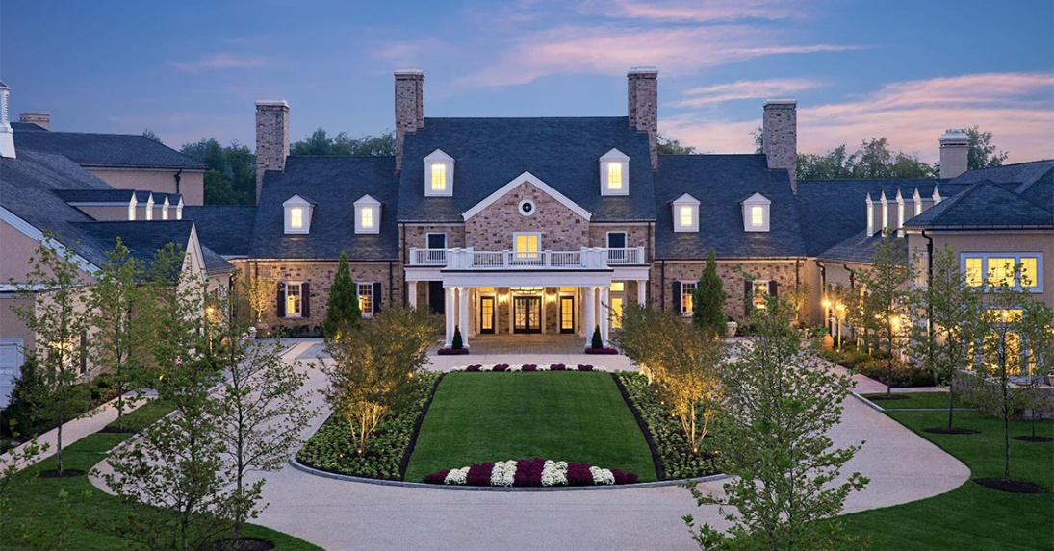

Instagram:


Post 2: Promo – Capri Palace Jumeirah

Facebook/Instagram Copy: Finally, we can say “arrivedici” to quarantine! Italy is welcoming visitors once again, meaning now is the perfect time to plan your grand adventure. As your travel advisor, I can arrange every step of your trip so you can stress less and enjoy more. Plus, I have access to exclusive offers like a complimentary private 3-hour island boat tour and VIP amenities from Capri Palace Jumeirah. Contact me to learn more and start planning!

Twitter Copy: Italy is welcoming visitors once again! As your travel advisor, I can arrange every step of your trip so you can stress less and enjoy more. Plus, I have access to exclusive offers like a complimentary private 3-hour island boat tour and VIP amenities from Capri Palace Jumeirah.

Image*:
Facebook and Twitter:
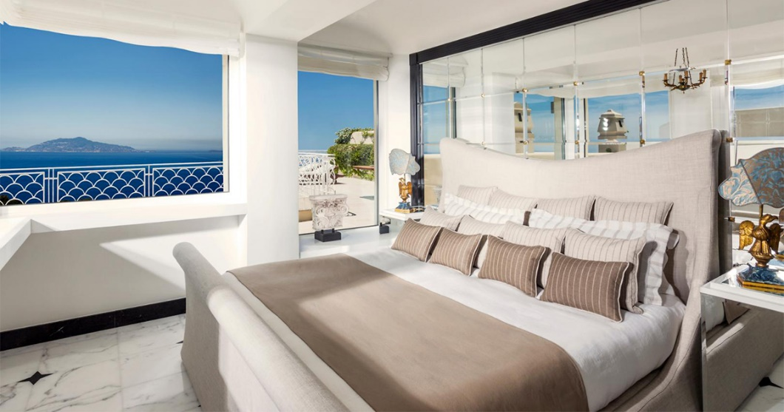
Instagram:
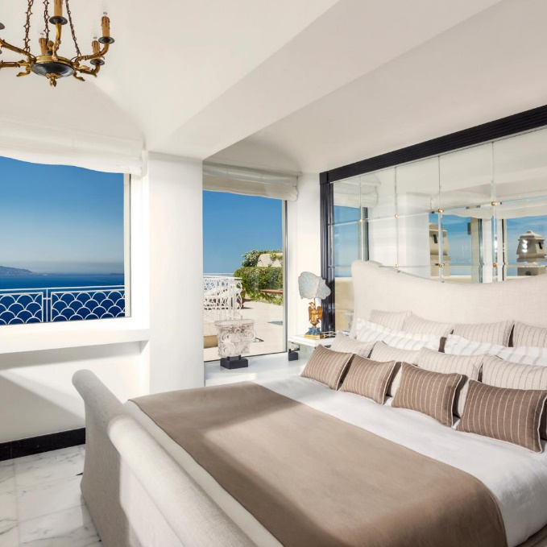

Post 3: Promo – Loews Atlanta

Facebook/Instagram Copy: Experience a modern hotel with old-world hospitality in the perfect “Hotlanta” location in the heart of Midtown. Book your stay at Loews Atlanta through me to get every 4th night free this summer! Plus, as your travel advisor I can also get you VIP amenities like a $100 hotel credit and breakfast for two daily.

Twitter Copy: Experience a modern hotel with old-world hospitality in the perfect “Hotlanta” location. Book your stay at Loews Atlanta through me to get every 4th night free this summer! Plus, I can also get you VIP amenities like a $100 hotel credit and breakfast for two daily.

Image*:
Facebook and Twitter:
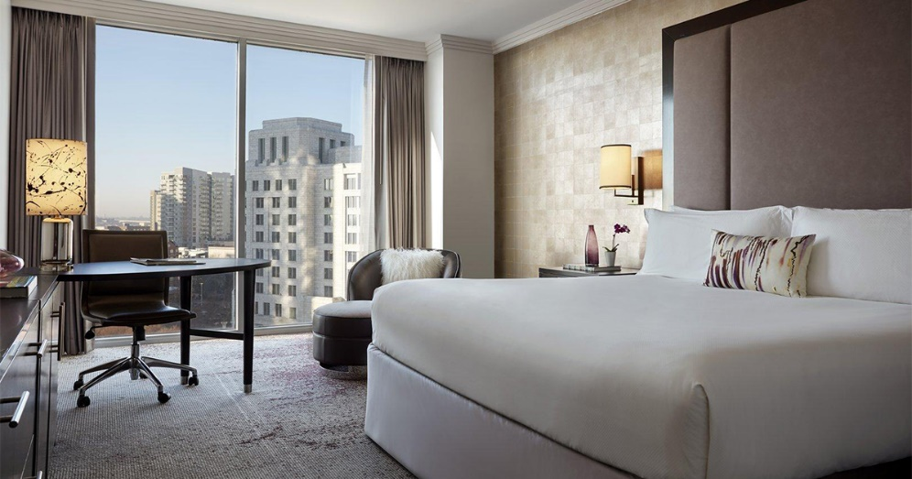
Instagram:
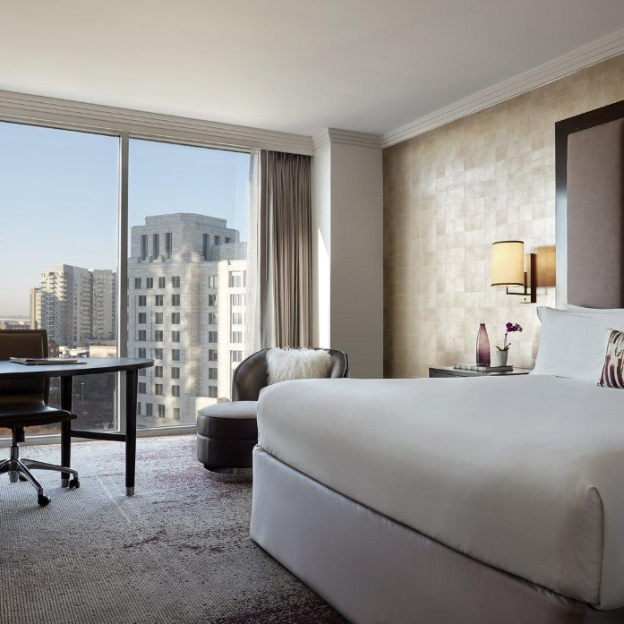

Post 4: Promotion – Elewana Collection: Bush Properties

Facebook/Instagram Copy: Your vacation may have been put on pause last year, but that’s all the more reason to go big with an African safari experience this year. The tented camps and game drives from Elewana Collection are unlike anything you’ve ever imagined – and when you book through me, you’ll receive your own private vehicle and guide on all game drives, a VIP amenity valued at $100 and more! Contact me to start planning.

Twitter Copy: Your vacation may have been put on pause last year, but that’s all the more reason to go big this year with an African safari experience. Book an Elewana Collection property through me for your own private vehicle and guide on all game drives, a $100 VIP amenity and more!

Image*:
Facebook and Twitter:
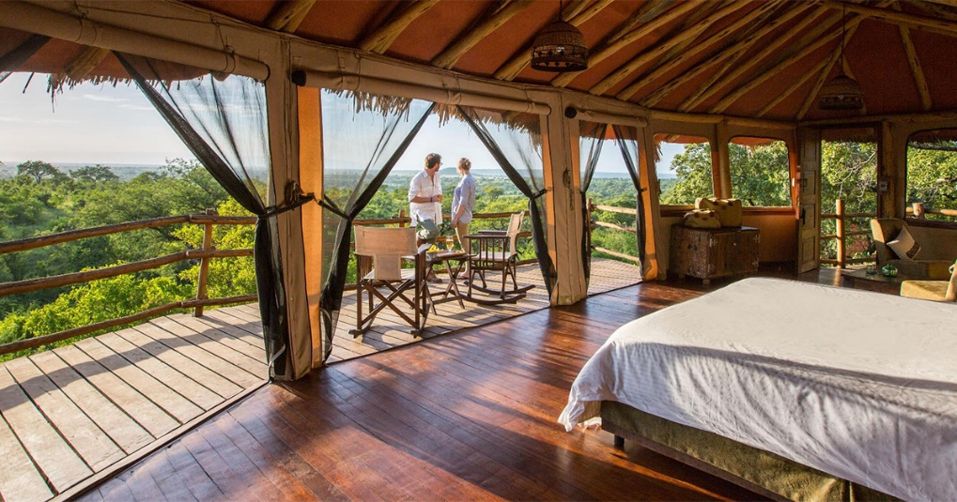
Instagram:
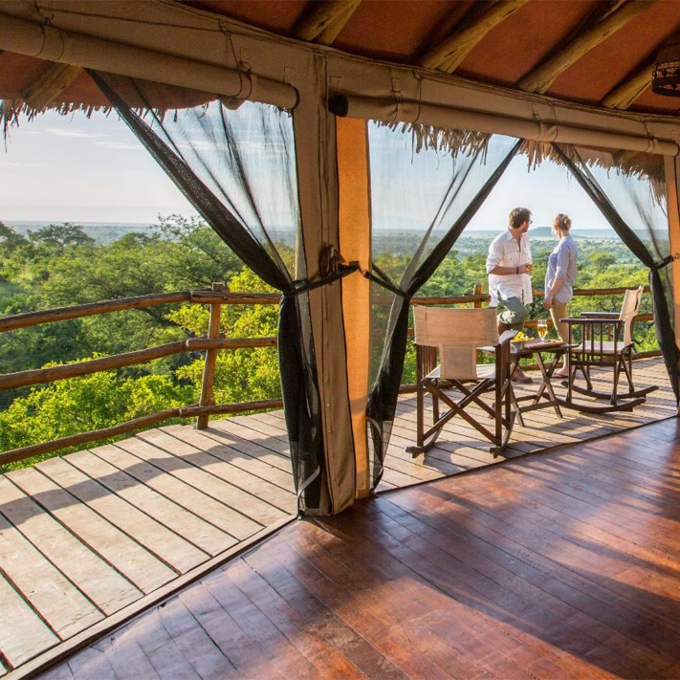

*Important Note: The images included in this toolkit may only be used by Internova Travel Group advisors and for posts relating to the SELECT program to comply with copyright limitations.

