Share the Summer SELECT Magazine to your Social Media

As your clients begin to feel more comfortable traveling, posting the latest version of the SELECT magazine is a great way to show the variety of extraordinary travel experiences that you can create for them. For your convenience, we have provided the copy and images below to share the latest SELECT Magazine to your social media channels. Feel free to personalize and share to let your followers know that they can book through you to gain the special perks that only SELECT offers.

Posting Tips:
To share a link on Instagram, place the link to the magazine in the bio of your profile. Then, post the below image and caption to your Instagram grid, and refer your audience to click the link in your bio for more information or to book with you.
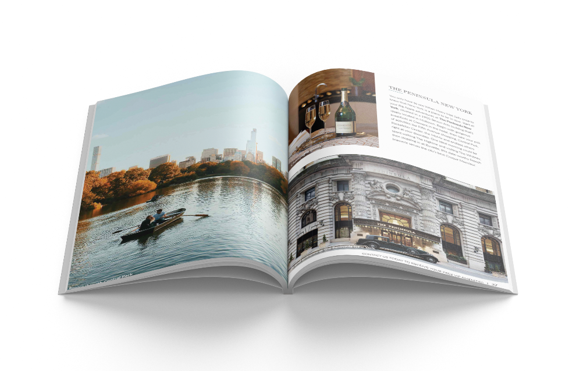
Link to magazine: https://issuu.com/codegreenx/docs/select-magazine-summer-issue-2021?fr=sYWFhMzM4MDU0ODU

Post Examples

Facebook/Instagram: Everyone has different reasons for traveling, but many of us get a similar feeling when we visit someplace new – a spark and feeling of awe that comes when we exposure our senses to the unfamiliar. If you’re craving that spark again but aren’t sure where (or how) to travel during times still filled with uncertainty, the Summer SELECT Magazine is your answer! With my insider knowledge on trips like the ultimate girls’ vacation to Los Angeles and top Michelin-starred restaurants in Europe, plus VIP amenities and top-of-the-line health verifications from our hotel partners, you’re bound to find inspiration for your next trip in these pages. And when you’re ready to book, I’ll be here to guide you every step of the way to ensure you feel that spark again!

Twitter: Craving a trip to somewhere new but aren’t sure where (or how) to travel during times still filled with uncertainty? The Summer SELECT Magazine is your answer! With my insider knowledge on destinations, you’re bound to find inspiration for your next trip in these pages.

Right click on an image below and save to your computer to post*:

L’Auberge de Sedona – Sedona, Arizona


En route for a night in Charleston, South Carolina
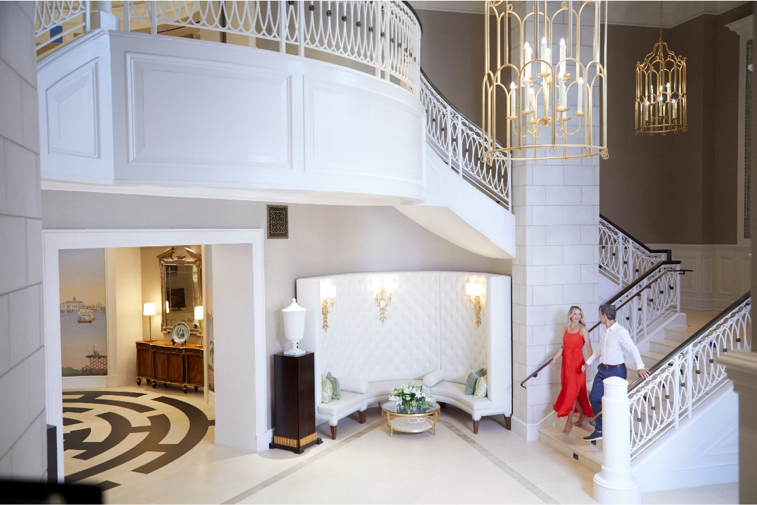

Half Moon Jamaica – Montego Bay, Jamaica
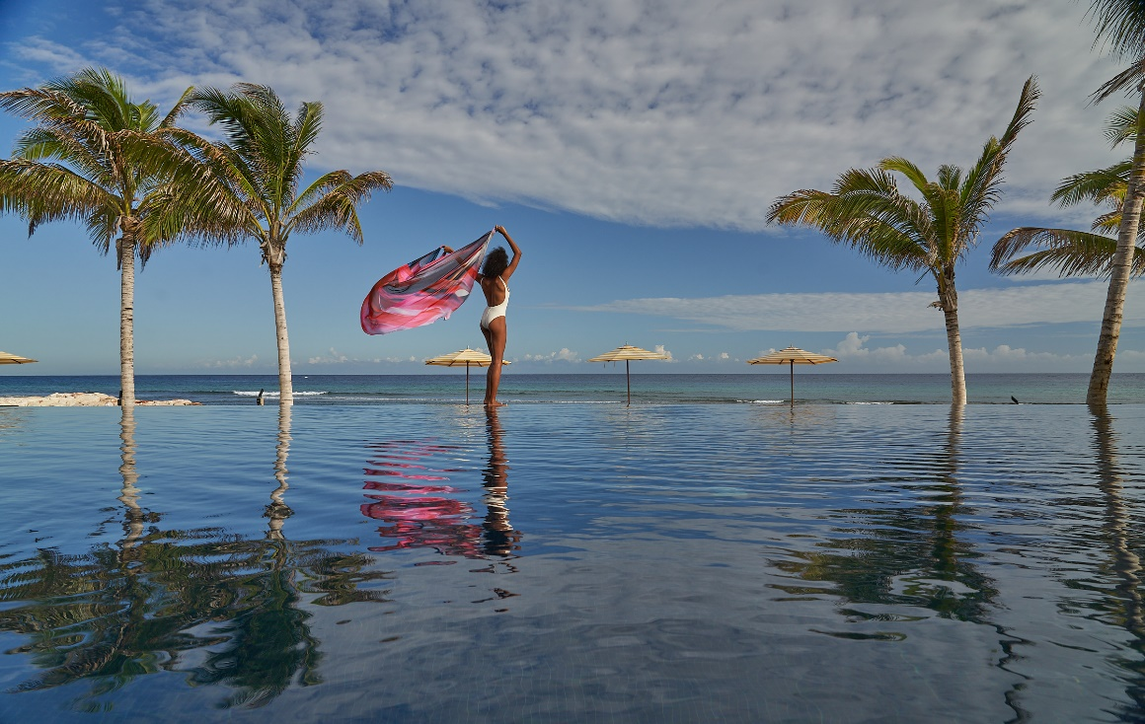

Puerto Rican architecture – Puerto Rico
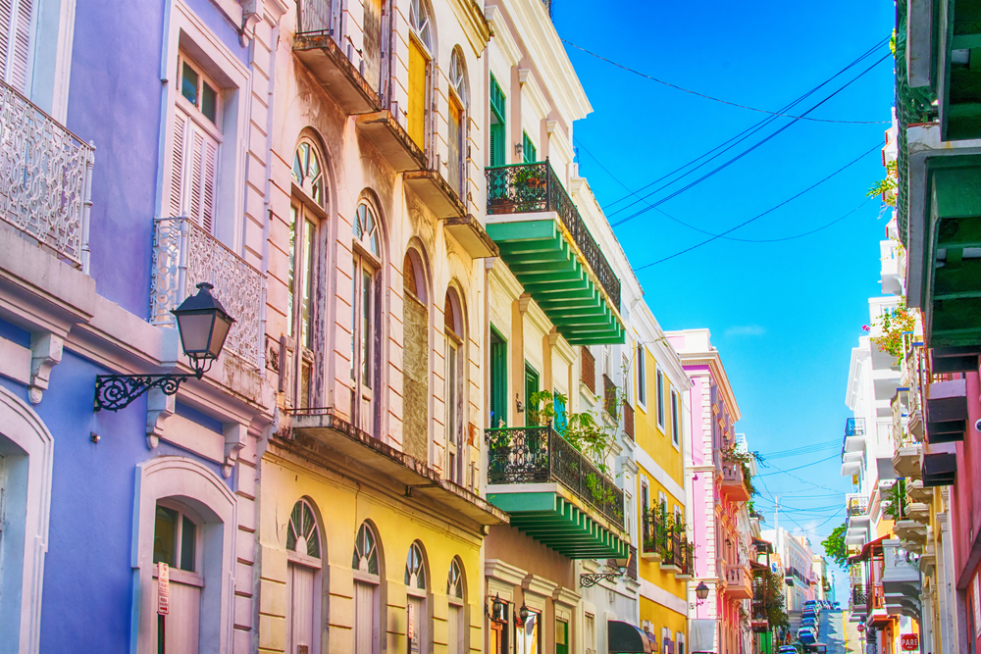

*Note: The images included may only be used by Internova Travel Group advisors and for posts relating to the SELECT Experiences program to comply with copyright limitations.

